ANNEHURST PIRANHAS | QTY: _______ X $20
AN ANNEHURST PIRANAHAS LIVES HERE | QTY: _______ X $20  Add $5 for personalization
MY CHILD IS AN ANNEHURST PIRANHA | QTY: _______ X $20
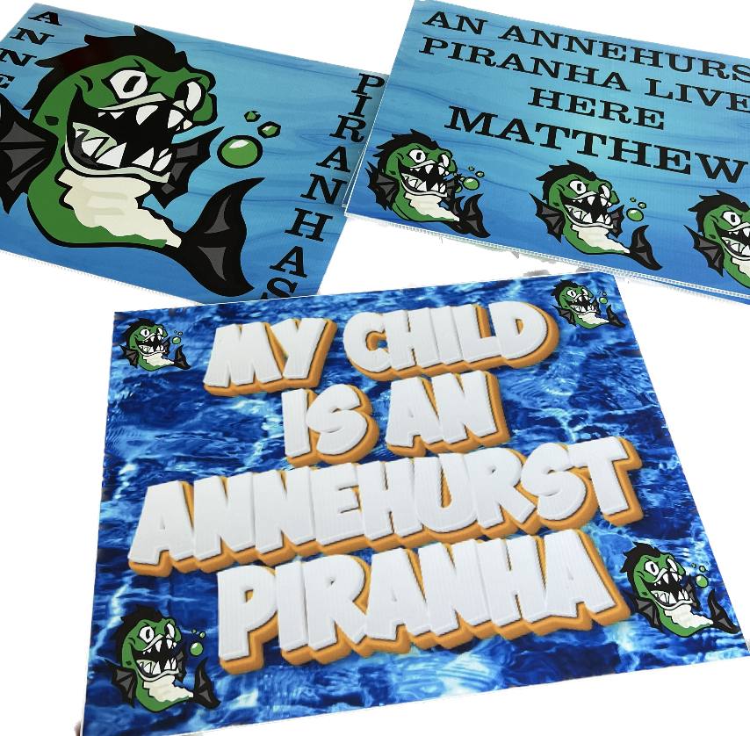

Submitted by
Phone
Email
Personalized

